1. 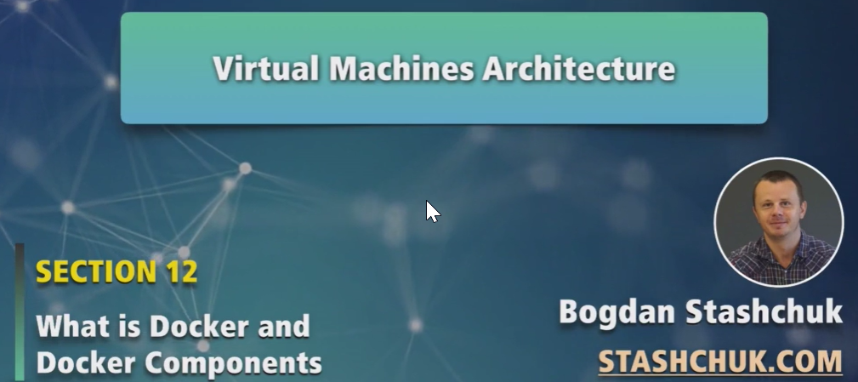
2. Let’s see how to create VM.  
   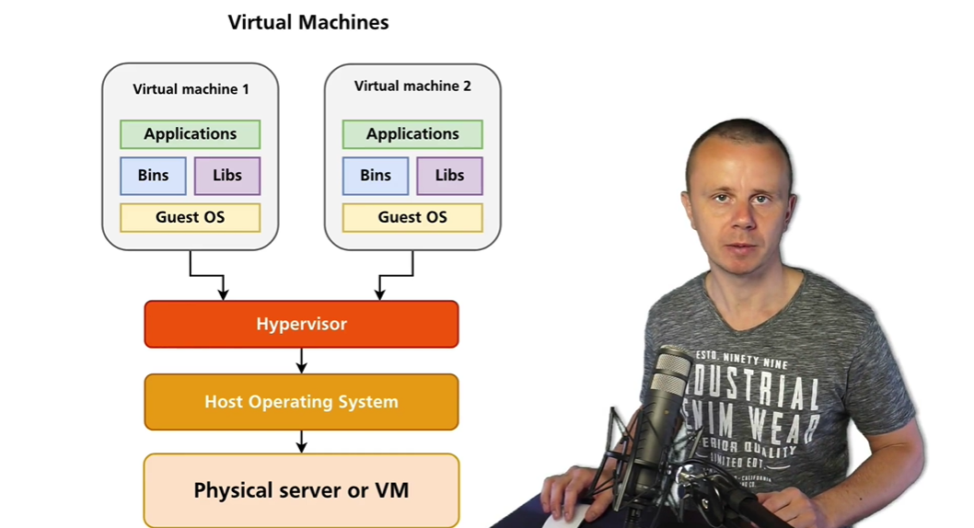
3. **First requirement**: You must have either physical server or VM (as inside VM, we can create another VM).
4. **Host Operating System**: It can be anyone such as Windows, MAC, Linux etc.
5. **Hypervison**: On top of Host OS, install it. There are many types such as   
   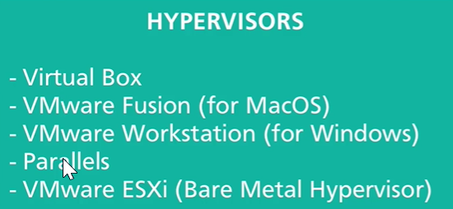  
   **VMware ESXi**: It is directly installed on the computer so no need for hosting OS.  
   So, Hypervisor may be running on
   1. Hosting OS which is running on physical server
   2. Virtual Machine.
   3. Directly on Hosting Machine (Physical Server) (in case of VMware ESXi).
6. **Virtual Machine 01:** Virtual machine is installed on top of hypervisor.
   1. The idea is that each VM has its own Guest OS.
   2. Each VM has its own set of binary files, executables, its own file system, dedicated resources like CPU, memory, Hard disk.
   3. Inside each VM, we are able to run applications.
   4. Applications running in one VM would be isolated from those running in other VM.  
      We can say that each VM is separate world or separate entity.